PALAKK SHRIVASTAVA

**STRATEGIC INNOVATION SIMULATION:** **BACK BAY BATTERY**

**SUMMARY**

The exercise is a strategic simulation where we assume the role of the President of Back Battery Bay, managing the battery portfolio. As the President, the responsibility is to make decisions around the R&D, investments and cost price of the batteries – Lithium and Ultracapacitor spread across 3 product types. The goal is to maximize the profit of the organization, sustaining and navigating through the sales trends across the years 2013 to 2020.

**EVALUTION OF RUN**

From the best run, Back Battery Bay could reach a cumulative profit of $250.02 in the year 2020. Below is the detailed analysis of the strategies for each year though out the run.

**YEAR 1: 2013**

For the first year of simulation, I just observed the trend of the market and did not make a very significant price change. The R&D investment was 90% of the allocated budget in the process improvement as I had learned of its impact in the multiple runs. Process improvement is important when it comes to reducing manufacturing cost.

**Result**: The sales variance for the runs was positive 20% for NiMH whereas, stable for UC after the first decision and a steep rise in the net income.

**YEAR 2: 2014**

Since the sales variance was high for NiMH thus, my decision was to reduce the prices of the NiMH to $9.5 and did not change the price of UC. My spending on R&D was equal for both the batteries and the same category.

**Result**: As a result of this, there was a decline in the net income however the sales variance became -1% and 6% for NiMH and UC.

My next strategy was to leverage the stable variance of UC.

**YEAR 3: 2015**

I reduced the price further by 1% of NiMH and increased the price of UC to $20.25 tap into the market. Due to the declined net income, the R&D budget allocation reduced but my decision was a 50-50 split for both batteries. The implication of this was reduced net income, and the unit sales had decreased significantly in power tools category for both the batteries.

**Result**: The sales variance was -25% for NiMH which became a concern as it meant actual sales was less than the forecasted sales

**YEAR 4: 2016**

My focus was on recovering from the decreasing net income and balancing the variance. Also, the sales were decreasing thus, price sensitivity had to be considered before making the decision as it meant losing consumers. Thus, I reduced the prices of both the batteries to $8.6 and $19.20 respectively to maintain the competitive edge in the market. Along with this my strategy was to keep a watch on the potential customer base as there was competition

**Result**: There was steep decline in unit sales for NiMH but the variance was better; there was a rise in unit sales of UC for power pack category, and +51% variance. Also, there was changing need of the more valued feature of Recharge time.

**YEAR 5**: **2017**

After a constant decline in the operating profit, and repeated warning, this was a crucial year being the CEO of the company. My focus was to increase the operating profit for which I further reduced the unit price to $8.3 and $18.7 for NiMH, UC. To accommodate the rising demand for recharge time, I invested in recharge time feature as well.

**Result**: There was a decline in the operating profit, unit sales and negative variance.

**YEAR 6: 2018**

From the previous runs I adjusted the price based and adjusted the R&D investment. Reduced the price further to meet with the demand of the reducing the price to $8 and $18. This worked out well as per the market. The operating profit increased drastically along with the unit sales in the power tools category.

Sales variance improved to positive for both the batteries. My strategy at this point was to maintain the results through to the next 2 years.

**YEAR 7 & 8 : 2019 - 2020**

As the unit sales had increased and variance was not very high, I leveraged the situation to reap operating profits and increased the price of both the batteries by a small amount. By doing this I could get the profit of $32.2M. Following a similar strategy for the last year helped me maintain a good sales variance and complete the run up to year 2020 and achieve a cumulative profit of **$250.02 M** towards the end of the simulation

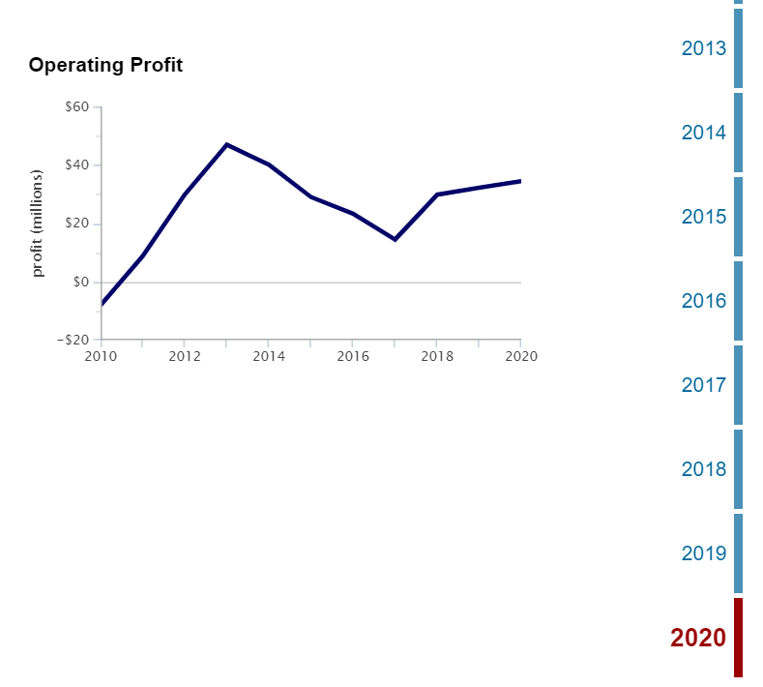**Fig. 1** **OPERATING PROFIT**

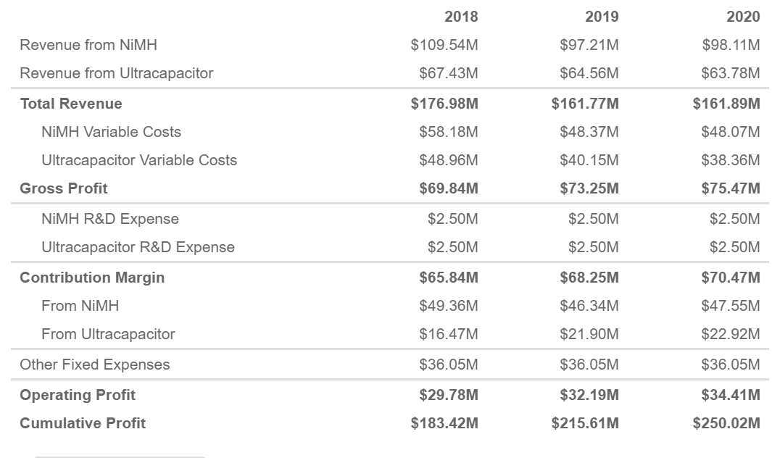



**Table 1.** **CUMULATIVE PROFIT – $250.02M**

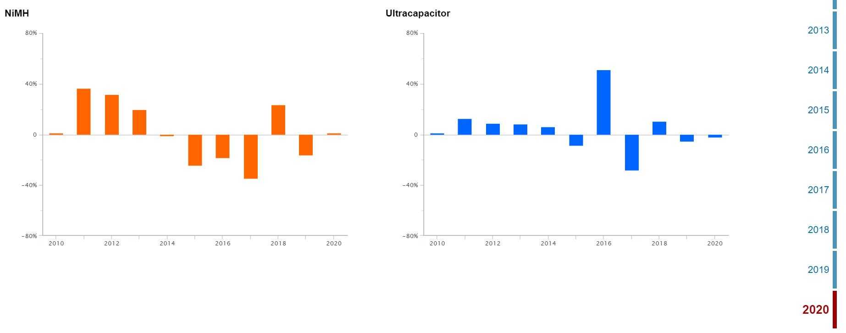**Fig. 2 SALES VARIANCE**

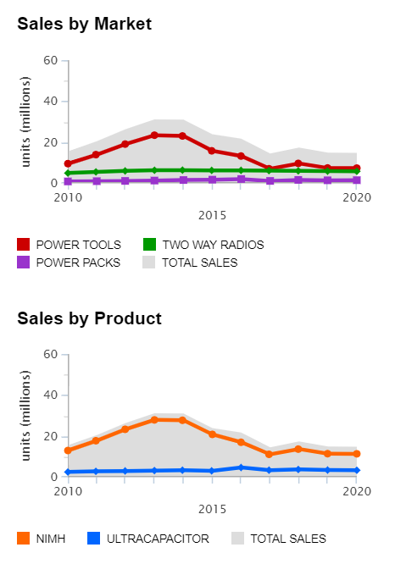 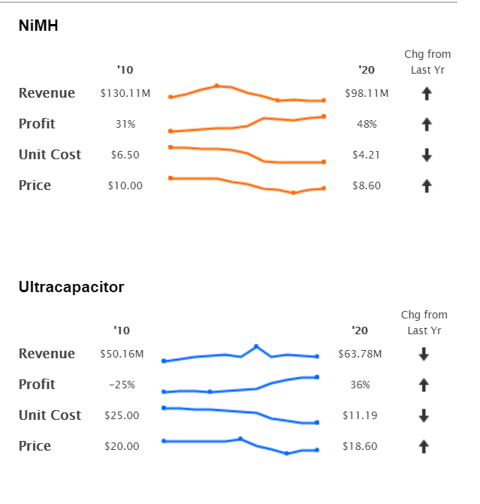

**Fig.3 SALES Fig. 4 OVERALL CHANGE**

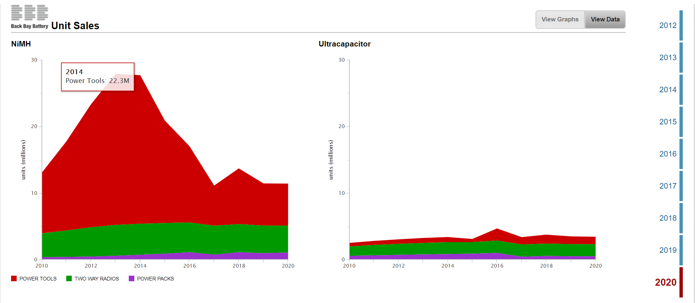

**Fig. 5 UNIT SALES**

**SUCCESS AND FAILURES**

My first success came after 31 failed runs. These were very difficult to get by as I was still understanding the whole process and how each parameter impacted the net profit and income. The initial couple of runs that I attempted, I was observing more than making drastic decisions. I was able to comprehend the whole simulation after 3-4 runs, post which I started applying different strategies.

The initial few failures helped me assess where I was going wrong. For a larger part of the runs, I got stuck at year 2018 and would get fired with the cumulative profit in the range of $50 -$100M. I couldn’t complete most of these runs. On contemplating, I realized that I was not focusing on the news as much. I overestimated the sales which impacted the sales variance negatively resulting in a significant drop in the net income. This got me fired in the subsequent years. For, the part of R&D investment, I was investing more in self-discharge and energy density for UC as it was less than desired. This was apparently not very helpful as at the later part of the simulation, recharge time was needing more importance as per changing market.

This is when I adopted a new strategy. By now, I scaled a steep learning curve. I followed news at every step and experimented with the R&D budgets. An important thing that I had learned was to pay attention to the how the market was changing. This helped me assess how customer needs were changing. Based on this I started adjusting the unit price. This explained the price sensitivity of the customers and sales were fluctuating. It was necessary to have a competitive price to be able to sustain in the market.

Focusing on the above areas helped me achieve the first simulation run with the profit of $206M. I followed the similar strategy for next few runs where they were successful but with varying profits. To improve on this, I invested heavily on the process improvement of both the NiMH and UC. This was a major contributor to the success of the runs and became evident in the trial runs. It helped me bring down the per unit cost and increased the available profit, as well as bring down the variable price. Another factor is that, I was not utilizing the complete R&D budget earlier. While this increased the immediate profit at times, it was not useful in the long run. Thus, I started investing all the R&D budget equally which did help me. This helped me realize that R&D is important for an innovation product. I also utilized the budget for the Recharge time which was of more value to the customers in the year 2017 than the energy density of the battery.

I realized that there was a tradeoff between investing in process improvement and other features together of both NiMH and UC batteries. All could not be achieved and here comes the importance of decision making based on the immediate need. By being vigilant about these points helped me achieve in subsequent runs. Overall, I can say that holistic review is required to sustain a business inclusive of customers, changing market trends, product, price and R&D.

**PERSONAL PERSPECTIVES**

This was my first experience of a decision-based simulation, I can gladly say it was one of the best exercises I have undertaken in my academic stint. Business decisions and strategies have always been my area of interest. I like reading about how the businesses are driven and it has always intrigued me. Thus, this simulation was a perfect combination of strategizing based on decisions. I have had the privilege to work under the guidance of c-suite executives in my internship and just getting a gist of part of the job they do, daily, in a real setting with so much capital on stake amazes me.

Through the simulation I was able to gain a good understanding of aspects that must be considered while running a business as an executive managing a portfolio of products across an organizational platform. This requires a horizontal view of the whole domain. The decision making is as necessary a part as tough it is. At some points it got difficult because outcome was unpredictable, and availability of more information was helpful. Regardless of the statistics and graphs available, it was just one part of the simulation. In an industry there are more aspects that contribute towards profit that were not considers. Many times, it felt as if though, the results were similar even after using different strategies.

The simulation overall does not explain the reason for a particular result because there is not enough supporting data and explanation that covers the whole product landscape. Due to this many decision were intuitive and I could gain confidence in taking decisions only in the later runs. For example, no matter what changes I made for 3rd year, there was a significant income drop. I was not very well versed with the process of forecasting, this was a good learning. Along with this was a good practice with graphs and interpretation.

The whole simulation was very intriguing and got me wonder what the results could have been if it were a group exercise. I think there could have been much more exchange of ideas and perspectives as simulation would replicate the actual scenario involving teams. In entirety, simulation has been a unique and creative learning experience for me.

**HOW THE SIMULATION INFLUENCED MY THINKING PROCESS**

**Analytical thinking**

The simulation was a great mental exercise. The whole process helped me gain insight on the complicated process of sales insight. In the real-life scenario, it is very important to make timely decisions and this simulation engrained that for me. It helped me practice and brush up my analytical skills and reinforced the importance of data driven decision making. Towards the end of simulation runs, I was able to look through the changing graphs and trends and make quicker decisions. I was able to foresee the repercussions of my decisions and that changed my thought process for the better. I had been on the creator side of the reports and graph as a part of academic project or my professional tenure but being the decision – maker I realized how data influences the decisions. The dashboards and graphs reading are a skill that develops with practice and simulations was a start for me. Visualized data not only helped me gain insight, but also assured the decisions were backed by a solid reasoning.

**Problem-solving**

In the simulation, there are various ways to get through the end of 8 years, but finding the optimum way is the goal. This is synonymous to a complex problem solving which I was able to learn. Making way amidst the permutation and combination of the possibilities is one skill that is integral to any professional pursuit and I was able to get a hand-on experience of that. Initially I was skeptical to make drastic moves in the simulations but later realized that, these situations are tackled through trial-n-error. It’s through continuous trying that I learned and its ok to make mistakes. However, this is not as simple in real life but gave me a crux of the whole situation.

**Conceptual understanding**

My understanding of the various concepts of business-like variable cost, income, sales variance had a good foundation built as I did not have a prior knowledge of these. These were integral to the whole process and sooner or later had to be focused on for the success of the runs. Thus, I was able to delve further into the sales/finance domain. Sometimes, I referred other sources for the terms I wasn’t versed, which taught to one or two additional related concepts. For example, Sales variance was a major fluctuating variable of the simulation and upon reading about it, I understood more accounting concepts like selling price variance, sales volume variance, which were also surprisingly embedded in the simulation and could be observe.

Along with this, the simulation re-established the value of customer perspective and choices. Major demand trends could be observed through the news that directly affected the profits if ignored. Also, the prices/features/services must be in synchronization with the company’s goals. Thus, it’s the balance between retaining customers amidst competition and hitting the mark with profit goals that helps a company flourish.

As much the simulation is an analytical skill, it also is a great practice for patience.

**DECISIONS THAT WERE CORRECT AND WHAT COULD HAVE BEEN DONE DIFFERENTLY**

During the initial few runs, many of my decisions were based randomly to observe. I was using a trial-n-error method which only converted to solid decisions during the later runs when my understanding was better on the whole simulation.

Some of the things that could have been done differently are –

* One of the major improvement areas could be focusing on the news from very start. Paying attention to the news at every step is absolute necessary to adapt to changing market. Initially I just surfed through the news whereas it was the news that majorly helped me in completing the simulation.
* Take in to consideration all the R&D sections and budget

I did not invest in other R&D categories for a larger part and would keep changing the budget in the category that was already populated at the start of the simulation. Initially I observed that profit margins could be increased with not investing some R&D budget however, this was clearly a wrong strategy realized later.

* One such category was that of process improvement which required investment. This was more necessary when the market changed and sales decline. During that period the prices must be reduced too which could have been offset by reducing the manufacturing cost at the start. This would have also helped me maintain a good profit margin through all times.
* Another approach that I could have taken differently was that of reducing the prices. When I started following the news, I always decreased the price of NiMH battery and did not consider doing the same for UC. Fluctuating prices of NiMH showed direct results however, I probably should have experimented more around reduced prices of UC too.
* Many times, I would reduce the price to the exact value that was reflected in the news and that did not help. I would still get fired which was overwhelming at times. I tried increasing the prices when sales were high for some of the runs to recover negative sales but that also did not work because of the high price sensitivity, leading me to get fired regardless. Finding the correct balance was a task.
* Another aspect was that of installed and potential customer base which I could not really work around with. I think some more research in that respect could have been useful. Another similar grey area was how to individually explore the categories power tools, Two-Way Radios and Power Packs. From the results Two-way radios and power tools still saw maximum potential customers but Power packs still had scope.

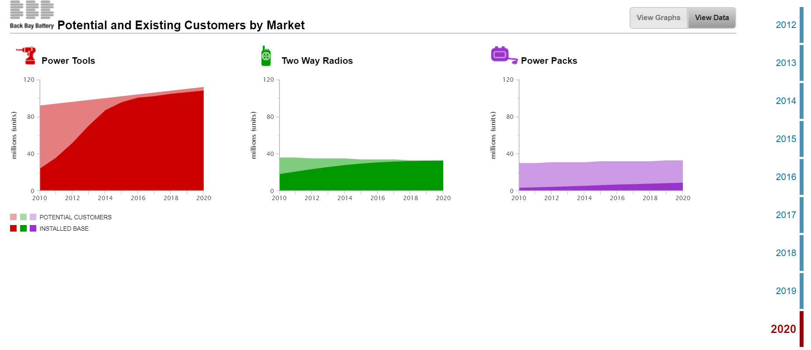

**FIG. 6 INSTALLED BASE/POTENTIAL CUSTOMERS**

* There is always a new learning when we explore, and below are the decisions that helped me achieve good results -
* I started following the news but did not do it blindly. I always tried to combine my strategies with the news update which proved helpful. When prices were to be cut down to $6.75 I kept the estimate between $8 -$9 which always resulted in a increase in income statement and maintaining profit.
* Also, for the later years of the simulation, I was able to figure out the range of prices that worked well, thus reduced prices accordingly which increased the unit sales and net income. I started to base my decisions on the unit sales of each category which helped me adjust the cost prices.
* Upon learning the impact process improvement had in the whole simulation, I invested heavily and equally for both NiMH and UC.
* Along with this I continued investing some budget in Recharge Time for optimization which was fruitful as its enhanced features. Rather Recharge Time area had a breakthrough in the later years, so the investment was worth. For fostering innovation continuous R&D process must be in place.
* I think my decision of not changing the prices much in the first 2 years, helped me scale maximum profit initially. I oversaw all the three main variable, sales variance, Net income and unit sales and prioritize based on situation which parameter needed focus. This was the best strategy overall.

**CONCEPT INTEGRATION**

The learnings from the course were pivotal in making decisions for the R&D and pricing. I could integrate the theoretical knowledge gained from the class with my participation in the simulation.

The foremost concept that comes to my mind is the **design dominance.** It is very clear in the simulation that customer potential in power packs could not be tapped completely as well as the other two categories. Thus, design dominance was in play. So, I could leverage my understanding of core competencies and invest in the areas where the company can grow. This way could increase the market share of the products.

Another process of **New product development** was useful for me as it could be directly implemented by monitoring the customer preferences, market trends and improving efficiency which are integral part of the process. Along with this came the predecessor strategic decisions. Throughout the course there was enough emphasis on the importance of strategizing, whether price, market deployment etc. As a part of this, I read through the case and instruction thoroughly. I tied to make sure that I did ample research on the organization. It also guided me to monitor trends, competition and other factors that helped in decision making of the strategic moves like R&D investment and changing price.

**Maintaining competitive advantage** could be practiced by keeping lower prices of the batteries and this was greatly useful in meeting needs of the customer as well as lead in the market. Process improvement had a direct impact on this which could help maintain profits even at lower operating costs. Thus, my understanding of price strategy was highly useful in the simulation.

Also, there was an element of **ambidexterity** that I could correlate with the simulations as the company was continuously improving and innovating and maintaining the older status. The company was agile in terms of being adaptive to old as well as new innovations areas.

Overall, the simulation was a very productive and engaging exercise.